DISTRIBUTED SYSTEMS

**A1.2: Web app using**

**Request – Reply Communication Paradigm**

Acu Raul-Mihai

30442

**Table of Contents**

1. **Project requirements**
2. **Implementation details**
3. **Conceptual architecture**
4. **Database design**
5. **Project requirements**

**Functional requirements:**

➢ Users log in. Users are redirected to the page corresponding to their role.

➢ Client role

o A client can view on his/her page all the flights in a list or table.

o A client can query for the local time of the flight arrival and departure cities computed based on cities geographical coordinates.

➢ Administrator role

o The administrator can perform CRUD operations on flights (Create, Read, Update and Delete)

➢ Each flight consists of the following information: flight number, airplane type, departure city, departure date and hour, arrival city, arrival date and hour.

➢ Each city has associated its geographical coordinates: latitude and longitude.

➢ In order to display the local time, the geographical coordinates of the city are passed to an external web service (e.g. http://new.earthtools.org/webservices.htm) which will return the actual time value.

➢ The simple users will not be able to enter the administrator page (e.g. by log-in and then copy- paste the admin URL to the browser)

**Implementation technologies:**

➢ Use the following technologies: HTML, Java Servlets and Hibernate ORM.

**Non-functional requirements:**

➢ Security: use authentication in order to restrict users to access the administrator pages

(cookies, session, etc.)

1. **Implementation details**

The project runs on an Apache Tomcat 8.0 server, using Java servlets for communication between the presentation layer and data entry layer and Hibernate ORM and an MySQL database.

**Apache Tomcat 8.0:** The Apache Tomcat® software is an open source implementation of the Java Servlet, JavaServer Pages, Java Expression Language and Java WebSocket technologies. The Java Servlet, JavaServer Pages, Java Expression Language and Java WebSocket specifications are developed under the Java Community Process. The Apache Tomcat software is developed in an open and participatory environment and released under the Apache License version 2. The Apache Tomcat project is intended to be a collaboration of the best-of-breed developers from around the world. We invite you to participate in this open development project. To learn more about getting involved.

**HTTP Java servlet:** Provides an abstract class to be subclassed to create an HTTP servlet suitable for a Web site. Servlets typically run on multithreaded servers, so a servlet must handle concurrent requests and be careful to synchronize access to shared resources. Shared resources include in-memory data such as instance or class variables and external objects such as files, database connections, and network connections. See the Java Tutorial on Multithreaded Programming for more information on handling multiple threads in a Java program.

**Hibernate ORM:** enables developers to more easily write applications whose data outlives the application process. As an Object/Relational Mapping (ORM) framework, Hibernate is concerned with data persistence as it applies to relational databases (via JDBC).

1. **Conceptual architecture**

Conceptual architecture is a form of architecture that utilizes conceptualism, characterized by an introduction of ideas or concepts from outside of architecture often as a means of expanding the discipline of architecture. This produces an essentially different kind of building than one produced by the widely held 'architect as a master-builder' model, in which craft and construction are the guiding principles

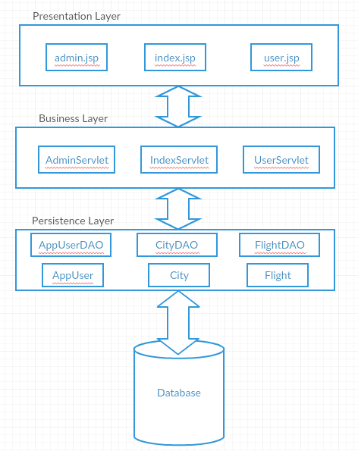

1. **Database design**

